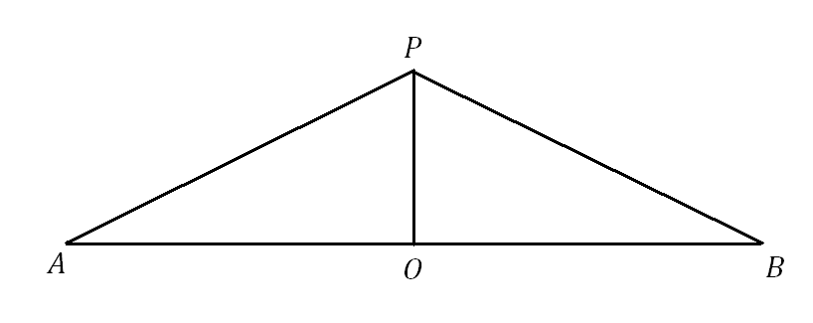
Given: $O$ is the midpoint of $\overline{AB}$;
$$\overline{PA}≅\overline{PB}$$

Prove: $∆POA≅∆POB$

